**Kafka Offset Monitoring 🡪 Video 2**

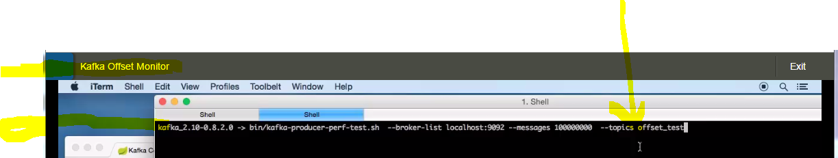

**Create topic and send messages.**

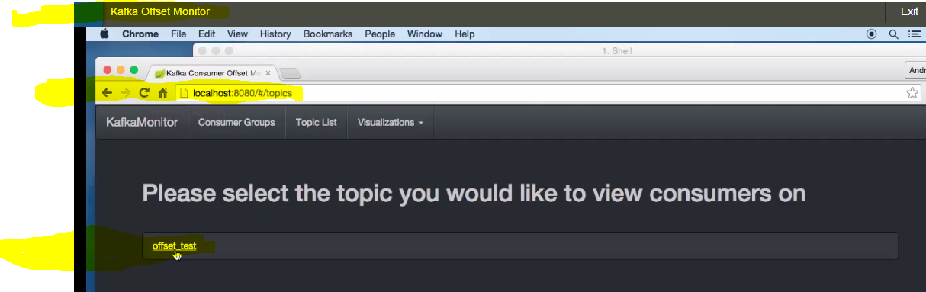

Click on offset_test topic , you wont see messages getting consumed yet.

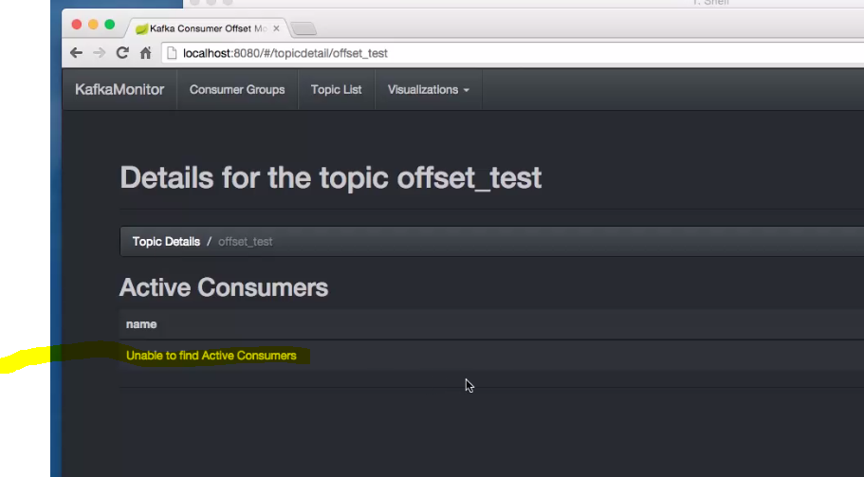

Open new shell and fire consumer consuming test.

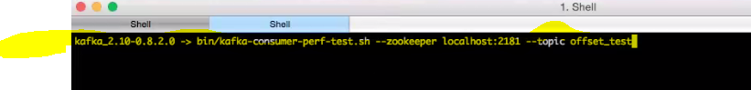

Refresh Topics again and you will see consumers showing up here.

